1. Right click on project (nextgen or Framework, whatever project you are working) and select Properties as shown in below screenshots.

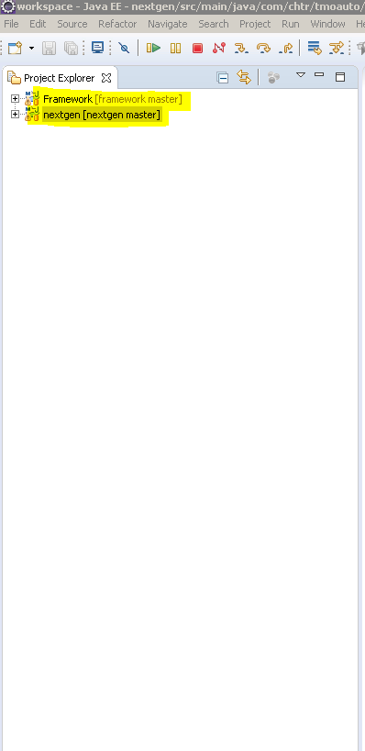

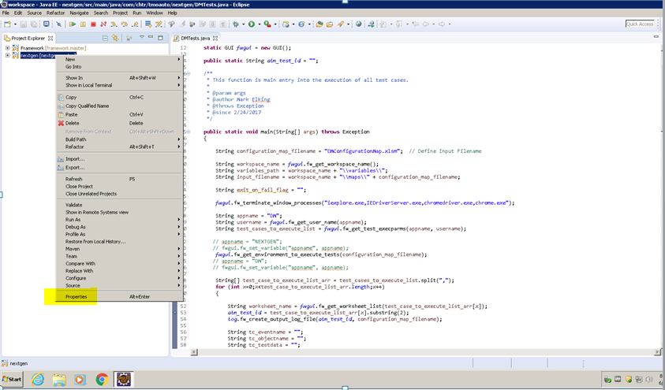

1. In above screen, select Libraries tab from below screen.

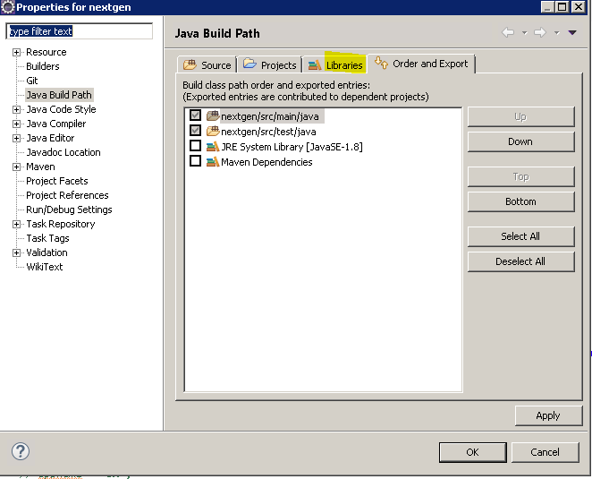

1. Then select and expand JRE System Library [JavaSE-1.8], you will see Program Files paths instead of Program Files (x86), so we need to change all the paths to this folder.

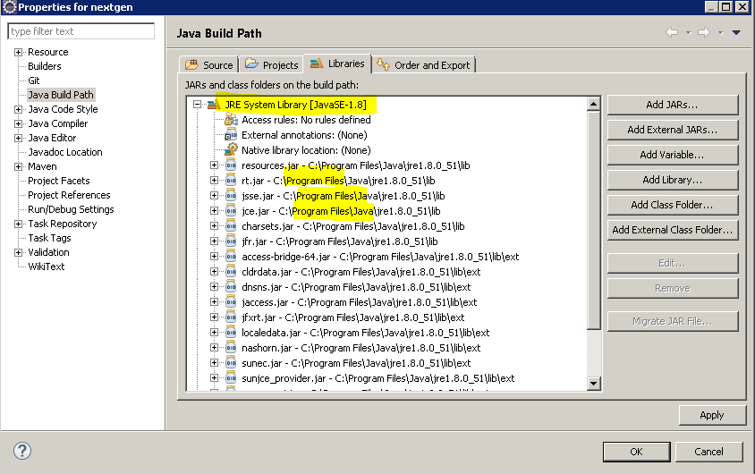

Select JRE System Library [JavaSE-1.8] as highlighted below and click Edit.

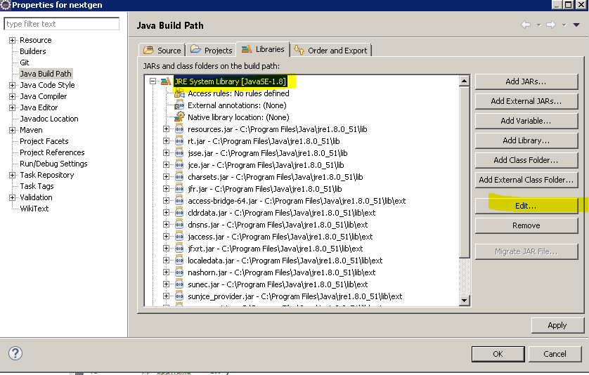

Select Alternate JRE which will enable the edit field and click Installed JRE’s… button shown in below screen shots.

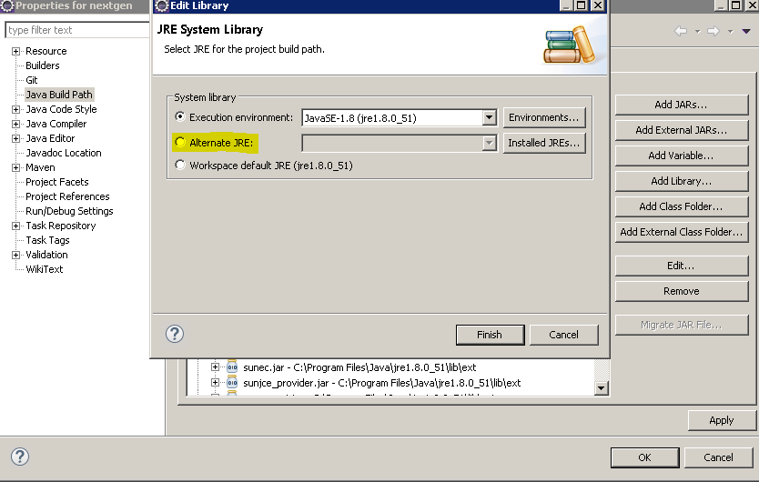

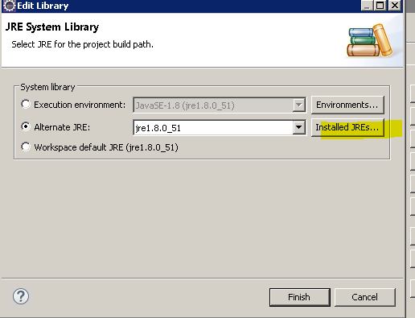

Select checked jre1.8.0… as shown highlighted below and click on Edit button.

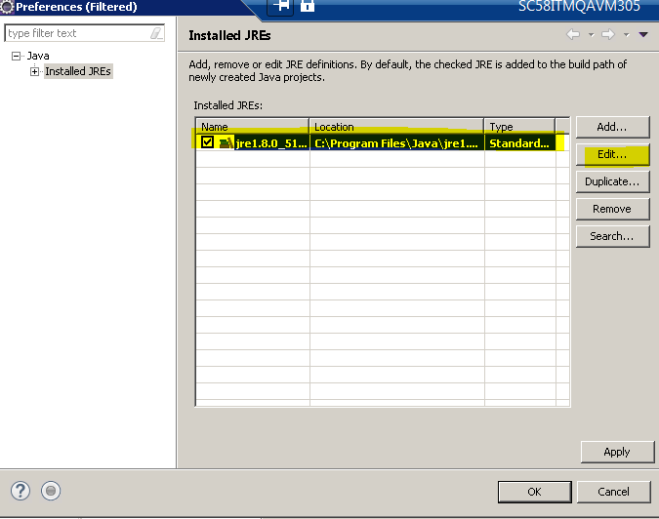

Right now you are seeing Program Files Path for Jre in JRE home field, now click Directory.

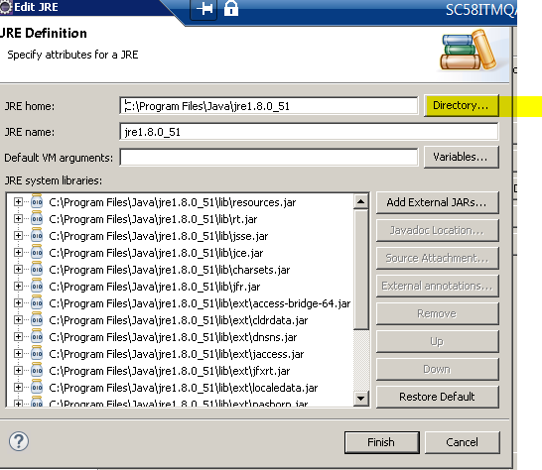

Go to and select jre1.8.0_51 folder under Program Files(x86) path under C drive and click Ok.

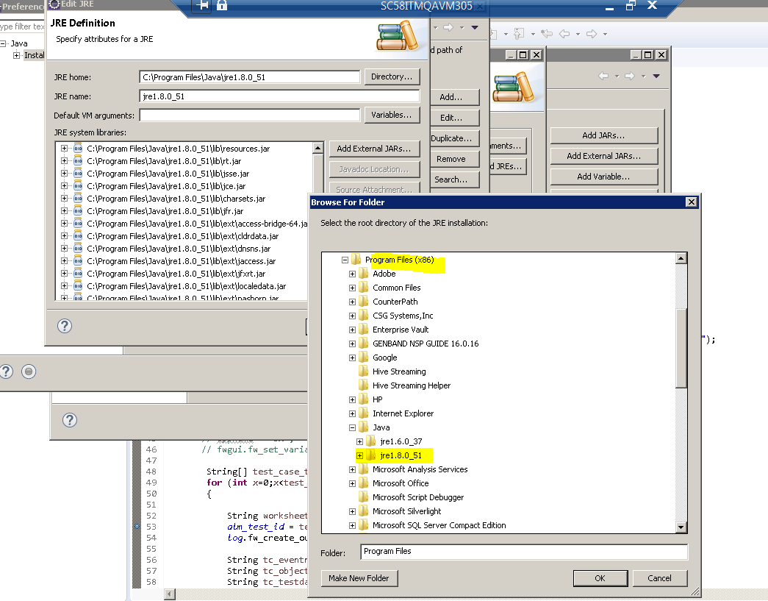

Now you will see different path for JRE home and change the JRE_name value by adding _32 at the end as shown in below screenshot and click finish.

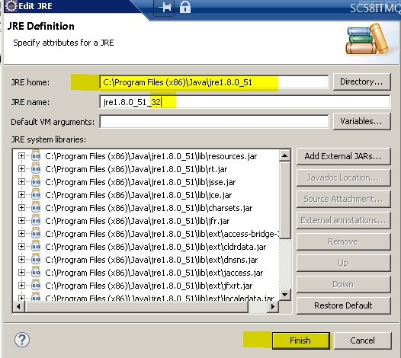

Click Apply and ok button as shown in below screen

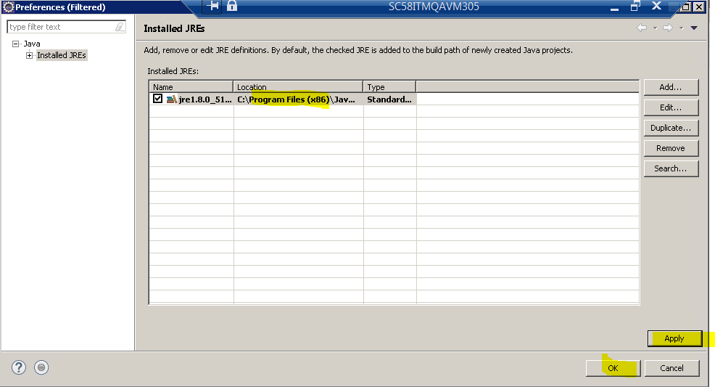

Click Finish.

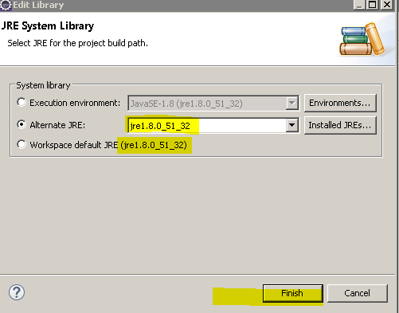

Click Apply and Ok.

